A Project Synopsis On

E-Commerce Product Review Management System Based on Opinion Mining and Sentiment Analysis.

Fourth Year of Engineering In

Computer Engineering

By

|  |  |  |  |
| --- | --- | --- | --- |
| **NAME** | **EMAIL** | **PHONE NUMBER** | **CLASS** |
| Sujith Nair | sujithnair97@gmail.com | 9757026664 | BE-3-26 |
| Apresh Pandit | p.apresh@gmail.com | 9004306968 | BE-3-28 |
| Sanal Pillai | sanal.pillai97@gmail.com | 9967637207 | BE-3-32 |
| Onkaar Sawant | sawantonkaar@gmail.com | 9969801166 | BE-3-39 |



Department of Computer Engineering

**Shah and Anchor Kutchhi Engineering College, Mumbai**

**University of Mumbai, Mumbai**

**Year 2017-2018**

**INDEX**

|  |  |  |
| --- | --- | --- |
| **Index Number** | **Table of Contents** | **PageNumber** |
| 1 | Introduction | 3 |
| 2 | Problem Definition | 3 |
| 3 | Block Diagram | 4 |
| 4 | Summary | 5 |
| 5 | References | 6 |

**1. Introduction**

There are many users who purchase products through E-commerce websites. Through online shopping many E-commerce enterprises were unable to know whether the customers are satisfied by the services provided by the firm. This boosts us to develop a system where various customers give reviews about the product and online shopping services, which in turn help the E-commerce enterprises and manufacturers to get customer opinion to improve service and merchandise through mining customer reviews. An algorithm could be used to track and manage customer reviews, through mining topics and sentiment orientation from online customer reviews.

**2. Problem Definition**

The main goal of our project is to provide a prototype system that could be used to track and manage customer reviews, the opinion of customers who bought that product, provide popularity of the customer’s searched product, and also provide details on frequently bought items through data mining techniques and sentiment analysis from online customer reviews.

**3. Block Diagram**

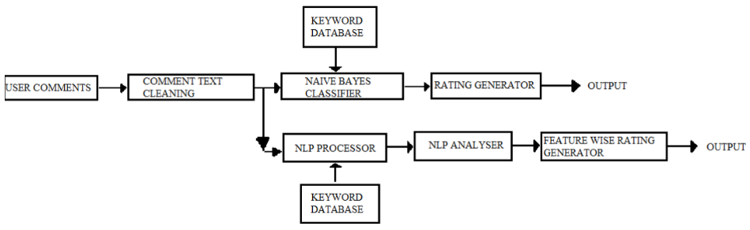

**4. Summary**

Sentiment analysis or opinion mining is a field of study that analyzes people’s sentiments, attitudes, or emotions towards certain entities. This paper tackles a fundamental problem of sentiment analysis, sentiment polarity categorization. Online product reviews from Amazon.com are selected as data used for this study. This paper provides a prototype that could be used to track and manage

customer reviews, the opinion of customers who bought that product, provide popularity of the customer’s searched product, and also provide details on frequently bought items through data mining topics and sentiment analysis.

**5. References**

**[1] Kushal Dave, Steve Lawrence, David M. Pennock. “Mining the peanut gallery: Opinion extraction and semantic classification of product reviews.” In Proceedings of WWW, 2003, pp.519–528.**

**[2] Callen Rain, “Sentiment Analysis in Amazon Reviews Using Probabilistic Machine Learning”, Swarthmore College Computer Society, November 2013**

**[3]Pooja Kherwa, Arjit Sachdeva, Dhruv Mahajan, “An approach towards comprehensive sentimental data analysis and opinion mining”. IEEE International Advance Computing Conference (IACC), 2014.**

**[4] Prashast Kumar, ArjitSachdeva, “An approach towards feature specific opinion mining and sentimental analysis across e-commerce websites”. 5th International Conference- Confluence The Next Generation Information Technology Summit (Confluence), 2014.**

**[5] K. L. S. Kumar, J. Desai and J. Majumdar, "Opinion mining and sentiment analysis on online customer review," 2016 IEEE International Conference on Computational Intelligence and Computing Research (ICCIC), Chennai, 2016, pp. 1-4. doi: 10.1109/ICCIC.2016.7919584**

**[6] D. Bin, S. Peiji and Z. Dan, "E-Commerce Reviews Management System Based on Online Customer Reviews Mining," 2010 International Conference on Innovative Computing and Communication and 2010 Asia-Pacific Conference on Information Technology and Ocean Engineering, Macao, 2010, pp. 374-377. doi: 10.1109/CICC-ITOE.2010.100**